Hi GNUGeeks,
I am trying to use OSMOCOM project for calling purpose. I tried the current master and remotes/origin/sylvain/testing branch also.
My Linux version is OpenSUSE 11.2 (2.6.31.5-0.1-default) and mobile model is C139.
And we used the model c140xor in the loader osmocon loader command.
I am able to download the loader.compalram.bin and layer1.compalram.bin and running the mobile project. I am also using the telnet for configuration. But it is stopping at following state:
Mobile Output:
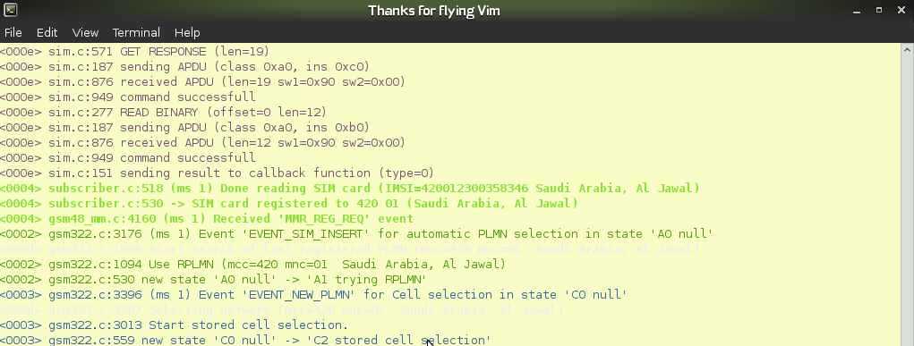
Layer1.compalram.bin Output: